 |  | Journal of XX
Journal homepage:
https://semarakilmu.com.my/journals/
ISSN: XXXX-XXXX
Title of Manuscript (Capital Letter of Each Word; Font type: Calibri; Font size: 16; Align Left)
Full Name¹, Corresponding Author^{1,}*, Author² (All Authors names must be written in a FULL NAME; Font type: Calibri; Font size: 12; Paragraph: Align Left)

Given Name | Family Name | Email
1. First Author | 1. First Author | 1. firstauthor@gmail.com
2. Second Author | 2. Second Author | 2. secondauthor@gmail.com
3. Third Author | 3. Third Author | 3. thirdauthor@gmail.com
4. Fourth Author | 4. Fourth Author | 4. fourthauthor@gmail.com

Note: Please add more rows (right click at item no.4>>insert>>insert row below), for authors more than 4 people
¹ | Department of Aeronatical, Automotive and Offfshore Engineering, Fakulti Kejuruteraan Mekanikal, Universiti Teknologi Malaysia, 81310 Skudai, Johor, Malaysia
² | Department of Mechanical Engineering, Faculty of Engineering, Kano University of Science and Technology, Wudil, Nigeria
ARTICLE INFO |  |  | ABSTRACT
Article history:  Received 29 October XXXX  Received in revised form 1 December XXXX  Accepted 9 December XXXX  Available online 10 December XXXX |  |  | Abstract should state a short introduction of background study, problem statement, purpose of the research, briefing about the used method, principal results and major conclusions. These six items should be included in abstract section (Compulsory). Citation or References and non-standard or uncommon abbreviations should be avoided in the abstract. The number of words should not exceed 350.
Keywords:
Minimum three keywords; avoid too general and too specific keywords; CDF Letters (Please use semicolon as separator)

1. Introduction

The first sentence should start here [1]. Should have one spacing after section header. The indent of the first line of paragraph should be 0.63cm. Content in body paragraph should be written with the Font style: Calibri; Font size: 12; Paragraph: Justify; Line spacing: 1.0. For example: The last few decades have witnessed vast research on new types of heat transfer fluids, namely nanofluids. Nanofluid is a fluid that contains nanometer-sized solid particles. The nanofluid was introduced by Choi et al., [2] and it has been proven to give better heat transfer efficiency compared to conventional fluids. Detailed reviews on the physical and thermal properties of nanofluids can be seen in review papers by several authors [3-5]. Important note: Citation cannot stand alone as subject or object. It just as a supportive to a statement. For example, “was also conducted by [4]", should be written as “was also conducted by Uithof et al., [4]” (et al., must be in italic style)
Second paragraph starts here (no spacing between paragraphs). For example: A nanofluid can be produced by dispersing metallic or non-metallic nanoparticles or nanofibers with a typical size of less than 100 nm in a base liquid.
Generally, in manuscript, should have: 1. Introduction (research background and Literature Review); 2. Methodology; 3. Result; 4. Conclusion; Acknowledgment; References. You may add more if required. The style of the section header as bellow:
1. Introduction (Capital Letter of Each Word; No indent; Font style: Calibri & Bold; Font Size: 12)
1.1 Sub Section Header (Capital Letter of Each Word; No indent; Font style: Calibri & Italic; Font Size: 12)
1.1.1 Sub sub section header (Sentence case; No indent; Font style: Calibri & Italic; Font Size: 12)

Header level three (1.1.1) and above will follow header level three style. No spacing between each header. However, before starting the first paragraph, must have one spacing after the header.
In the last paragraph of introduction section, Authors should highlight the gap and significant of the research before write the objective of the research. These three items are very important and compulsory. ----End of Introduction Section----

2. Methodology
2.1 Figure Style and Format

For manuscript publication, all provided Figures must follow the standard of quality for publication. Authors must provide a high quality with high resolution Figure. Content in the Figure should be clear and readable as shown in Figure 1(b) (Especially, the font size of contour legend). For example, as in Figure 1:

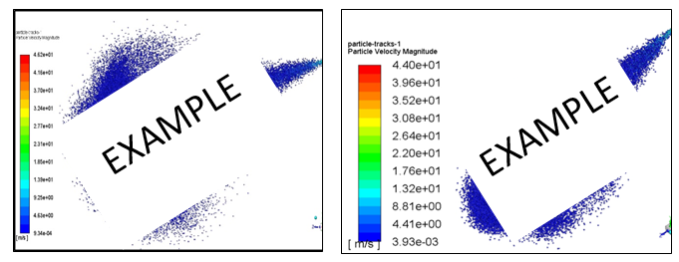
(a) (Font style: Calibri; Font size: 10) (b)
Fig. 1. Figure quality (a) Unclear and unreadable content (b) Clear and readable content (Font style: calibri; Font size: 11; Paragraph: Align left)

Each Figure must be discussed or mentioned in a body paragraph. The Figure must be placed under the paragraph that discussed about the Figure. Authors should try to make economical use of the space on the page; for example:

- avoid excessively large white space borders around your graphics;
- try to design illustrations that make good use of the available space—avoid unnecessarily large amounts of white space within the graphic;
- Use the suitable size of Figure. Not too big.
- Individual figures should normally be centered but place two figures side-by-side if they will fit comfortably like this as it saves space.
Captions should be below the figure. The caption SHOULD NOT be finished with a full stop (period). The captions should be set to (a) the width of the figure for wider figures (b) centered across the width of the figure, as shown below:

Fig. 1. In this case simply justify the caption so that it is as the same width as the graphic
Fig. 2. These two figures have been placed side-by-side to save space |  | Fig. 3. These two figures have been placed side-by-side to save space
Note: For long caption

Fig. 3. Figure with short caption (caption centred)
Note: For short caption

For example: A model of VFE-2 model was designed and fabricated in Universiti Malaysia wind tunnel under Malaysian Ministry of Education grant, as shown in Figure 2 below [4]. The designed was exactly based on the original profile of Chu and Lucking [6] as Figure 3.
Few years later, a new research group is formed to further investigate the flow structure on the blunt-edged delta wing, the team called as Vortex Flow Experiment (VFE-2). The main objective of the VFE-2 test was to validate the results of Navier-Stokes calculations and to obtain a more detailed experimental data. The VFE-2 experiments were carried out for both sharp and blunt leading edge shape delta wing [1-3].
Fig. 2. Comparison of experimental measurement and Numerical studies above VFE-2 configurations at α=13° [2]

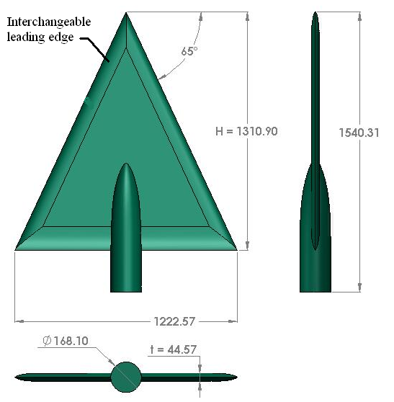
Fig. 3. UTM-LST delta wing VFE-2 profiles

Mat et al., [7] has performed a comprehensive flow visualization studies on blunt-edge delta wing. The primary vortex is developed at certain chordwise position and progress upstream with angle of attack; however, there is no data in VFE-2 indicating that the vortex progressed up to the Apex region with angle of attack increases.

2.2 Table Style and Format

Table should be placed at the center. Each Table must be discussed or mentioned in a body paragraph. The Table must be placed under the paragraph that discussed about the Table. Font style and font size of content in the Table are Calibri and 10, respectively. The content must be align left. The font size of Table caption is 11. The caption SHOULD NOT be finished with a full stop (period). The captions should be set to the width or within of the Table.

Table 1
Place the caption above the table. Here the caption is wider than the table
Distance (m) | Velocity (ms^{–1})
A | 1
B | 2
C | 3
D | 4

Table 2
Here the caption is shorter than the table
Reynolds number, Re | Velocity, V
A | 1
B | 2

2.3 Equation Style and Format

All equation that mentioned in body paragraph should be written as Eq. (1). Please use Microsoft Equation in order to present an equation. The font size of equation is 12. Each equation must be numbered as follow:

(1)

3. Results
3.1 Pressure Distribution

For example: This section discusses the results obtained from the surface pressure measurement study. The effects of angle of attack, Reynolds number and leading edge bluntness are discussed in the next sub section.

3.1.1 The effect of angle of attack

The test configuration for this experiment is in Table 1. Nevertheless for the experiment at Reynolds number of 2×10⁶, the angle of attack was limited to α = 23° only.

Table 1
The values of Reynolds number and velocity
Reynolds number, Re | Velocity, V
1×10⁶ | 18 m/s
2×10⁶ | 36 m/s

To differentiate the effects of Reynolds number, the experiments was also performed at two speeds of 18 m/s and 36 m/s that corresponding to 1×10⁶ and 2×10⁶ Reynolds number, calculated from Eq. (1) and summarize in Table 1.

$Re=\frac{ρVx}{μ}$ (1)

where the dynamic viscosity, μ, density of air, 𝜌 and length, x were taken as 1.846 ×10⁻⁵ kg/ms${10}^{-5}$, 1.18 kg/m³ and 0.874 m respectively.

4. Conclusions

In conclusion part, Author should highlight the finding of their research that respond to the research objective. For example: The experimental data of UTM-LST VFE-2 model at high angle of attack is presented here. More experiments are needed to verify this complicated flow topology.

Acknowledgement
This research was funded by a grant from Ministry of Higher Education of Malaysia (FRGS Grant R.J130000.7824.4X172).
(Note: This part is compulsory. If this research was not funded by any grant, please write “This research was not funded by any grant”)

References
The list of references should only include works that are cited in the text and that have been published or accepted for publication. Personal communications and unpublished works should only be mentioned in the text. Reference style should be in Chicago style. There have two options to write the Chicago style for the reference list. First, do it manually as demonstrated in this video. Please use this link for the DOI number. Second, for authors that using EndNote software (tools for reference management- Very recommended), Akademia Baru provides an output style that supports the formatting of in-text citations and reference list. Please download the output style in this link and save it in your Endnote style (C:\Program Files (x86)\EndNote X8\Styles) as shown below:

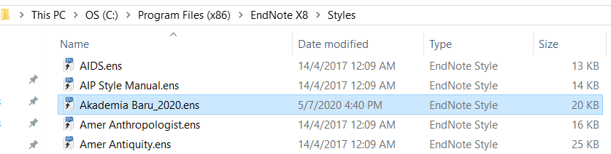

After that, open your Endnote software and choose “Akademia Baru_2020” as the selected style.

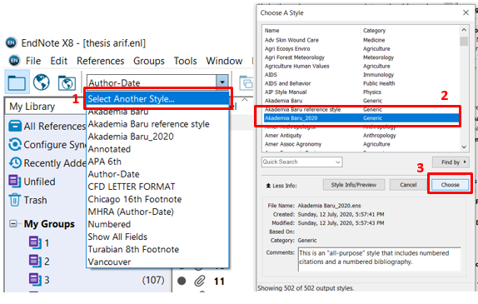
Open your Microsoft word file that has been cited with some references, go to EndNote tab and change Style to Akademia Baru_2020.

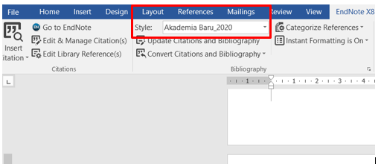

Next, click the Configuration Bibliography and set the hanging indent to 0.960 cm and font size to 10.

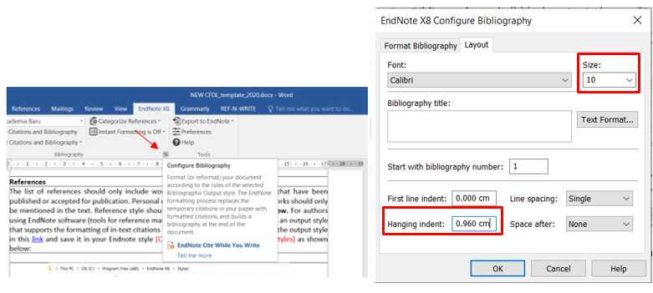

After that, press Alt+Ctrl+Shit+s to call Style. Go to Endnote Bibliography and click modify. Tick the Automatically update. Next, click the format list and select paragraph.

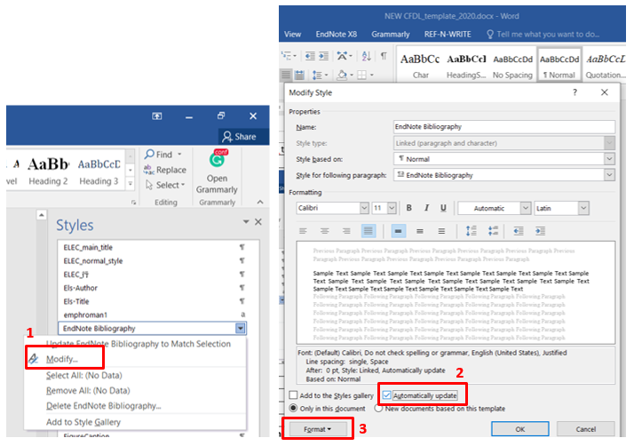
Change “before” and “after” to zero, and line spacing to “single”.

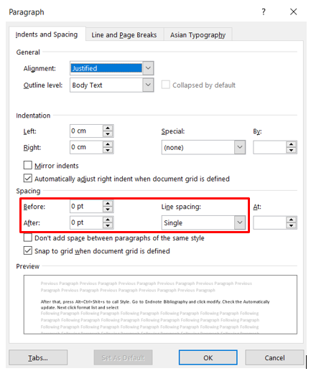

References (Reference style: Chicago style – must write DOI) Minimum 15 references
[1] Hummel, D. (2008). Chapter 17 – The International Vortex Flow Experiment 2 (VFE-2): Objectives and Overview. RTO-TR-AVT-113, Page 17-1 – 17-20.
[2] Luckring, J.M. and Hummel, D. (2008). Chapter 24 – What Was Learned From The New VFE-2 Experiments. RTO-TR-AVT-113. https://doi.org/10.2514/6.2008-383
[3] Mat, Shabudin Bin, Richard Green, Roderick Galbraith, and Frank Coton. "The effect of edge profile on delta wing flow." Proceedings of the Institution of Mechanical Engineers, Part G: Journal of Aerospace Engineering 230, no. 7 (2016): 1252-1262. https://doi.org/10.1177/0954410015606939
[4] Said, Mazuriah, Shabudin Mat, Shuhaimi Mansor, Ainullotfi Abdul-Latif, and Tholudin Mat Lazim. "Reynolds Number Effects on Flow Topology Above Blunt-Edge Delta Wing VFE-2 Configurations." In 53rd AIAA Aerospace Sciences Meeting, p. 1229. 2015. https://doi.org/10.2514/6.2015-1229
[5] Luckring, James M. "Initial experiments and analysis of blunt-edge vortex flows for VFE-2 configurations at NASA Langley, USA." Aerospace Science and Technology 24, no. 1 (2013): 10-21. https://doi.org/10.1016/j.ast.2012.02.005
[6] Konrath, Robert, Christian Klein, and Andreas Schröder. "PSP and PIV investigations on the VFE-2 configuration in sub-and transonic flow." Aerospace Science and Technology 24, no. 1 (2013): 22-31. https://doi.org/10.1016/j.ast.2012.09.003
[7] Fritz, Willy. "Numerical simulation of the peculiar subsonic flow-field about the VFE-2 delta wing with rounded leading edge." Aerospace Science and Technology 24, no. 1 (2013): 45-55. https://doi.org/10.1016/j.ast.2012.02.006
[8] Chu, J. and Luckring, J.M. (1996). Experimental Surface Pressure Data Obtained on 65⁰ Delta Wing across Reynolds Number and Mach number Ranges. NASA Technical Memorandum 4645. (Sharp-edged report)

NOTE: | Please follow exactly as requested in the template especially for the red font. It will speed up your paper publication process time

* Corresponding author. E-mail address: author.mail@gmail.com (Corresponding Author’s name) https://doi.org/10.37934/XXX.17.4.XX

